The Thinking Thing

***You can write a brief sub title here***

By

Fabricio Tosi

**Title of Your Book**

©Copyright 2022 Author Name, Title

**All rights reserved**

No part of this publication may be reproduced, stored in a retrieval system, or transmitted, in any form or by any means, electronic, mechanical, photocopying, recording or otherwise, without the express written permission of the author.

**Name of Printer Goes Here**

**ISBN:** 000-1234567890

**Your Organization Title here**

An Example Incorporated Company

0000 Example Street, Sample Suite

State, City & Zip

0123-456-7890

*Free book template downloaded from:*

https://usedtotech.com

admin@usedtotech.com

Contents

About the Author iv

Foreword vi

How to use this template? 1

Second Chapter Title 5

Third Chapter Title 9

# About the Author

When you create pictures, charts, or diagrams, they also coordinate with your current document look. You can easily change the formatting of selected text in the document text by choosing a look for the selected text from the Quick Styles gallery on the Home tab.

On the Insert tab, the galleries include items that are designed to coordinate with the overall look of your document. You can use these galleries to insert tables, headers, footers, lists, cover pages, and other document building blocks. You can also format text directly by using the other controls on the Home tab. Most controls offer a choice of using the look from the current theme or using a format that you specify directly.

## This is level 2 heading!

To change the overall look of your document, choose new Theme elements on the Page Layout tab. To change the looks available in the Quick Style gallery, use the Change Current Quick Style Set command. Both the Themes gallery and the Quick Styles gallery provide reset commands so that you can always restore the look of your document to the original contained in your current template.

You can also format text directly by using the other controls on the Home tab. Most controls offer a choice of using the look from the current theme or using a format that you specify directly. To change the overall look of your document, choose new Theme elements on the Page Layout tab. To change the looks available in the Quick Style gallery, use the Change Current Quick Style Set command.

You can also format text directly by using the other controls on the Home tab. Most controls offer a choice of using the look from the current theme or using a format that you specify directly. To change the overall look of your document, choose new Theme elements on the Page Layout tab. To change the looks available in the Quick Style gallery, use the Change Current Quick Style Set command.

**Author Name**

Title of the Author Here

# Foreword

When you create pictures, charts, or diagrams, they also coordinate with your current document look. You can easily change the formatting of selected text in the document text by choosing a look for the selected text from the Quick Styles gallery on the Home tab. On the Insert tab, the galleries include items that are designed to coordinate with the overall look of your document. You can use these galleries to insert tables, headers, footers, lists, cover pages, and other document building blocks. You can also format text directly by using the other controls on the Home tab. Most controls offer a choice of using the look from the current theme or using a format that you specify directly.

## This is level 2 heading!

To change the overall look of your document, choose new Theme elements on the Page Layout tab. To change the looks available in the Quick Style gallery, use the Change Current Quick Style Set command. Both the Themes gallery and the Quick Styles gallery provide reset commands so that you can always restore the look of your document to the original contained in your current template.

You can also format text directly by using the other controls on the Home tab. Most controls offer a choice of using the look from the current theme or using a format that you specify directly. To change the overall look of your document, choose new Theme elements on the Page Layout tab. To change the looks available in the Quick Style gallery, use the Change Current Quick Style Set command.

### This is level 3 heading!

You can also format text directly by using the other controls on the Home tab. Most controls offer a choice of using the look from the current theme or using a format that you specify directly. To change the overall look of your document, choose new Theme elements on the Page Layout tab. To change the looks available in the Quick Style gallery, use the Change Current Quick Style Set command. Most controls offer a choice of using the look from the current theme or using a format that you specify directly. To change the overall look of your document, choose new Theme elements on the Page Layout tab. To change the looks available in the Quick Style gallery, use the Change Current Quick Style Set command.

The Thinking Thing

Chapter 1

# How to use this template?

Looking for a free template of book for writing a book? You can use this professionally formatted Word book template for creating a **nicely formatted book** for online submission or for printing through any self-publishing company. This book template is especially created for preparing small books in 5 x 8 paperback. You will definitely find this Word template useful in formatting your book. The heading above these two paragraphs is a **“Level 1”** heading. Everything has been professionally organized and styled through Ms. Word’s style-sheets. You can start your sections or chapters with this Level 1 heading.

## Perfect formatting for self-authors

If you love writing books then you should definitely use this easy to use yet nicely formatted book layout for your next book. The heading above this paragraph is **“Level 2”** heading. Everything is formatted using predefined styles so instead of making any manual change in the formatting, you should modify the associated styles to let your changes effectively apply at every instance of that formatting. Feel free to personally use this outstanding book template in any of your fiction or non-fiction work. This is more than a blank book template in Microsoft Word; this is a complete book design for commercial printing & publishing.

## Print-ready typesetting & layout

The layout, design, formatting, automatic table of contents –everything has already been included in the template and this is for your **Personal Use Only**. We have included every necessary section into this book writing template. The starting pages are numbered using Roman numerals. However, everything is still modifiable for you. Even if you are not very good with Microsoft Word, still by using this template, you can make your book look professional. Either write your book from scratch or copy your existing content into the template, you’ll definitely love it. Make sure you check the **“Navigation Pane”** to know about the different levels of headings and also check the **“Styles”** group for available styles. This book template is formatted into **“Sections”**. Every Section has its own properties, please also take care of these things when adding new sections into the template.

## Adding new content

For adding new chapters in this template, simply copy these dummy texts entirely and paste them at the insertion point from where you need to start a new chapter. Otherwise, you can write your content from scratch using the predefined styles in the template. Please also note that this template uses **“Different First Page”** & **“Different Odd/Even Pages”** through Microsoft Word’s sections. Insert new chapter in a separate section.

## Using chapter title on the header

If you want to write chapter title on the header instead of using author name then you can modify it on the header of the section you are working on. Using sections is easy in Microsoft Word, if you don’t know about modifying sections then **please Google** about inserting & using sections in Ms. Word, you’ll certainly find many articles on Microsoft Word’s sections.

## Our “Important Notes”

Please first also read our “Important Notes” document attached in the download package. Our free templates normally consist of dummy text throughout the document so before you submit your book for final publishing, make sure there **remains no placeholder text** in the manuscript. You’re allowed to download, modify and use our free resources for your personal use only.

## Help us by accrediting!

If you find this book template helpful in your writings then please spread the word and appreciate us by sharing these awesome and free templates with others as much as you can so that many people will also take benefits of our great free resources. Please remember that this template is for your **PERSONAL USE ONLY**. For any questions, please write to us at the following addresses:

admin@usedtotech.com

https://usedtotech.com

***

## This is level 2 heading

You can also format text directly by using the other controls on the Home tab. Most controls offer a choice of using the look from the current theme or using a format that you specify directly. To change the overall look of your document, choose new Theme elements on the Page Layout tab. To change the looks available in the Quick Style gallery, use the Change Current Quick Style Set command. Both the Themes gallery and the Quick Styles gallery provide reset commands so that you can always restore the look of your document to the original contained in your current template. You can also format text directly by using the other controls on the Home tab. Most controls offer a choice of using the look from the current theme or using a format that you specify directly.

Capitulo 2

# estados de un proceso

Veamos otra vez la suma de un listado de numeros, que hemos utilizado de ejemplo en el capitulo anterior.

Inicialmente la lista contiene 5 numeros, y esa es toda la informacion que tenemos del problema hasta ese momento. Llamaremos al conjunto de datos, "contexto" del problema.

Hemos encontrado la solucion despues de realizar 4 operaciones de suma entre 2 numeros. Han sido 4 pasos.

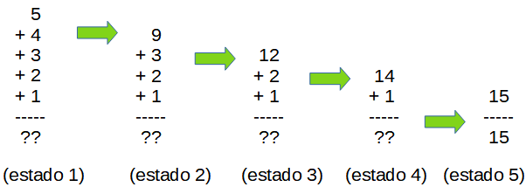

Observad que, en cada paso, despues de cada suma, el conjunto de datos ha cambiado.

Cada vez que realizamos una operacion sobre los datos, el contexto cambia de estado.

Y entre los posibles estados de un proceso, distinguiremos

- un “estado incial”,

- un “estado final”, y

- un conjunto de “estados intermedios”.

Por ejemplo, en el caso de una partida de ajedrez.

El “estado incial” sera cuando las fichas estan colocadas en la posicion de salida, antes de que se haya realizado ningun movimiento.

El “estado final” sera cuando se ha dado jaque-mate, la partida termina, este es el estado al que queremos llegar.

Entre el estado inicial y el estado final, la partida cambiara de estado cada vez que un jugador realice un movimiento, estos seran los “estados intermedios”.

Imaginemos ahora que en mitad de una partida de ajedrez, quisieramos dejar el juego por hoy, para continuar manyana desde el mismo punto en que lo hemos dejado.

Para poder continuar manyana desde el mismo punto, sera necesario recordar el estado en que la partida habia quedado.

Para recordar el estado del juego podriamos escribir en un listado la posicion de las fichas sobre el tablero, asi podriamos reconstruir la partida para continuar desde el mismo punto.

En este caso, la informacion del estado sera la posicion de las fichas, y este es el conjunto de datos que definen el contexto en este caso.

Utilizaremos la idea de estados del proceso para resolver el problema, buscando un camino que nos lleve desde el estado inicial hasta el estado final a traves de estados intermedios.

Podria existir un gran numero de estados posibles, pero queremos saber cuales de todos los posibles, son los que forman el camino que va desde el estado incial hasta el estado final.

El juego de ajedrez es de gran complejidad, y la partida podria atravesar por una elevado numero de estados diferentes.

Algo asi como 10 elevado a 120.

Veamos graficamente un ejemplo mas simple.

(grafico 3 en linea)

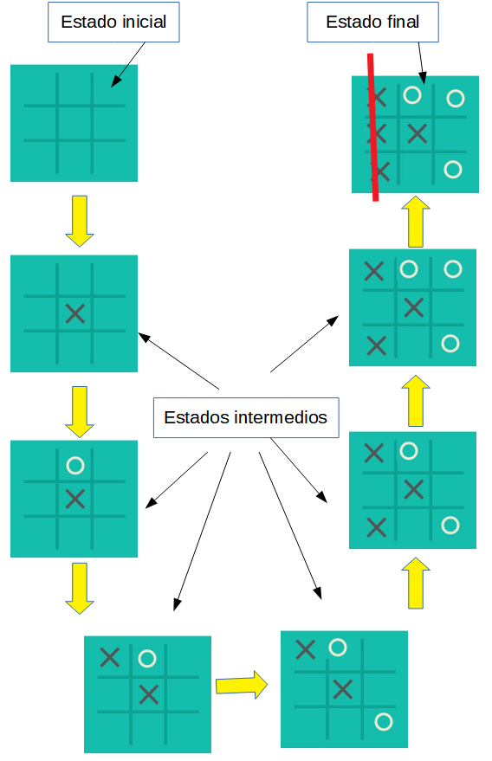

El dibujo muestra en el juego de 3 en linea, el camino a traves de distintos estados que va desde el estado inicial hasta uno de los posibles estados finales.

Para resolver problemas, utilizaremos el concepto de "estados", junto con una estructura llamada "Grafo".

En matemáticas y ciencias de la computación, un "grafo" es una estructura abstracta que representa relaciones entre objetos.

Un grafo consiste en un conjunto de nodos y un conjunto de aristas que conectan pares de nodos.

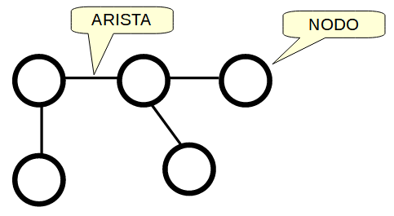

(grafico grafo)

Los grafos se utilizan de muchas formas diferentes para el analisis de muchos tipos de problemas diferentes, pero nosotros construiremos un grafo del siguiente modo.

Dentro de los nodos, colocaremos un estado del proceso, y las aristas que unen los nodos nos mostraran la relacion entre padres e hijos.

Veamos por ejemplo, como iniciariamos la construccion de un grafo con los estados del juego de 3 en linea.

Empezaremos poniendo el estado incial dentro de un nodo.

Los hijos del estado inicial mostraran todas las jugadas posibles, en este caso el tablero esta vacio y puede colocarse una ficha en cualquier casilla, y por lo tanto existen 9 jugadas posibles, crearemos los 9 hijos del estado inicial y los uniremos al padre con aristas.

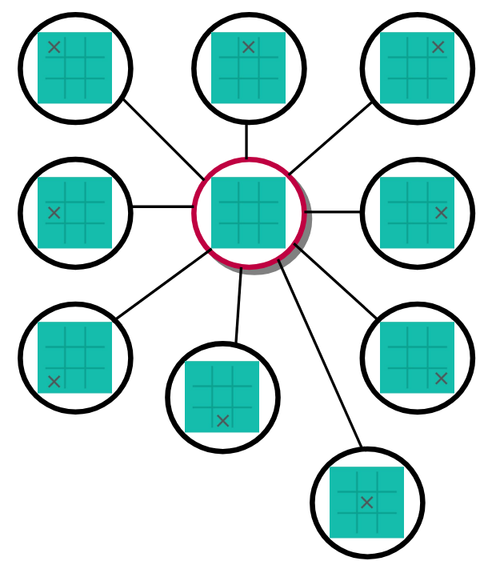

(dibujo)

A partir de estos nuevos estados tambien pueden realizarse jugadas validas, en todos estos tableros existen 8 casillas vacias y podemos colocar una ficha en cualquiera de ellas, generaremos todos los hijos de estos estados, los pondremos dentro de un nuevo nodo y uniremos el padre con el hijo a traves de una arista.

El grafo empieza a transformarse en una gran red de nodos y aristas. Si continuamos con este proceso de generar hijos por cada jugada valida desde cada nodo, la red final sera grande y compleja.

En el caso de este juego existen

9 * 8 * 7 * 6 * 5 * 4 * 3 * 2 = 362.880 estados posibles.

es decir que el grafo tendra 362.880 nodos.

Una vez generados todos los posibles estados podremos ver entre ellos cuales son los estados finales, y podremos ver el camino entre estados que llevan desde el estado inicial hasta un estado final.

En estas ideas estara basada la maquina de calculo.

En resumen,

hemos comentado a que llamamos estados de un proceso, que cosa es un grafo, y como es posible encontrar, entre todos los posibles, los "caminos" que nos llevan a la solucion de un problema.

Con estas ideas, estamos ya preparados para iniciar el experimento.

ooking for a free template of book for writing a book? You can use this professionally formatted Word book template for creating a **nicely formatted book** for online submission or for printing through any self-publishing company. This book template is especially created for preparing small books in 5 x 8 paperback. You will definitely find this Word template useful in formatting your book. The heading above these two paragraphs is a **“Level 1”** heading. Everything has been professionally organized and styled through Ms. Word’s style-sheets. You can start your sections or chapters with this Level 1 heading.

## Perfect formatting for self-authors

If you love writing books then you should definitely use this easy to use yet nicely formatted book layout for your next book. The heading above this paragraph is **“Level 2”** heading. Everything is formatted using predefined styles so instead of making any manual change in the formatting, you should modify the associated styles to let your changes effectively apply at every instance of that formatting. Feel free to personally use this outstanding book template in any of your fiction or non-fiction work. This is more than a blank book template in Microsoft Word; this is a complete book design for commercial printing & publishing.

## Print-ready typesetting & layout

The layout, design, formatting, automatic table of contents –everything has already been included in the template and this is for your **Personal Use Only**. We have included every necessary section into this book writing template. The starting pages are numbered using Roman numerals. However, everything is still modifiable for you. Even if you are not very good with Microsoft Word, still by using this template, you can make your book look professional. Either write your book from scratch or copy your existing content into the template, you’ll definitely love it. Make sure you check the **“Navigation Pane”** to know about the different levels of headings and also check the **“Styles”** group for available styles. This book template is formatted into **“Sections”**. Every Section has its own properties, please also take care of these things when adding new sections into the template.

## Adding new content

For adding new chapters in this template, simply copy these dummy texts entirely and paste them at the insertion point from where you need to start a new chapter. Otherwise, you can write your content from scratch using the predefined styles in the template. Please also note that this template uses **“Different First Page”** & **“Different Odd/Even Pages”** through Microsoft Word’s sections. Insert new chapter in a separate section.

## Using chapter title on the header

If you want to write chapter title on the header instead of using author name then you can modify it on the header of the section you are working on. Using sections is easy in Microsoft Word, if you don’t know about modifying sections then **please Google** about inserting & using sections in Ms. Word, you’ll certainly find many articles on Microsoft Word’s sections.

## Our “Important Notes”

Please first also read our “Important Notes” document attached in the download package. Our free templates normally consist of dummy text throughout the document so before you submit your book for final publishing, make sure there **remains no placeholder text** in the manuscript. You’re allowed to download, modify and use our free resources for your personal use only.

## Help us by accrediting!

If you find this book template helpful in your writings then please spread the word and appreciate us by sharing these awesome and free templates with others as much as you can so that many people will also take benefits of our great free resources. Please remember that this template is for your **PERSONAL USE ONLY**. For any questions, please write to us at the following addresses:

admin@usedtotech.com

https://usedtotech.com

***

## This is level 2 heading

You can also format text directly by using the other controls on the Home tab. Most controls offer a choice of using the look from the current theme or using a format that you specify directly. To change the overall look of your document, choose new Theme elements on the Page Layout tab. To change the looks available in the Quick Style gallery, use the Change Current Quick Style Set command. Both the Themes gallery and the Quick Styles gallery provide reset commands so that you can always restore the look of your document to the original contained in your current template. You can also format text directly by using the other controls on the Home tab. Most controls offer a choice of using the look from the current theme or using a format that you specify directly.

Chapter 3

# Third Chapter Title

Looking for a free template of book for writing a book? You can use this professionally formatted Word book template for creating a **nicely formatted book** for online submission or for printing through any self-publishing company. This book template is especially created for preparing small books in 5 x 8 paperback. You will definitely find this Word template useful in formatting your book. The heading above these two paragraphs is a **“Level 1”** heading. Everything has been professionally organized and styled through Ms. Word’s style-sheets. You can start your sections or chapters with this Level 1 heading.

## Perfect formatting for self-authors

If you love writing books then you should definitely use this easy to use yet nicely formatted book layout for your next book. The heading above this paragraph is **“Level 2”** heading. Everything is formatted using predefined styles so instead of making any manual change in the formatting, you should modify the associated styles to let your changes effectively apply at every instance of that formatting. Feel free to personally use this outstanding book template in any of your fiction or non-fiction work. This is more than a blank book template in Microsoft Word; this is a complete book design for commercial printing & publishing.

## Print-ready typesetting & layout

The layout, design, formatting, automatic table of contents –everything has already been included in the template and this is for your **Personal Use Only**. We have included every necessary section into this book writing template. The starting pages are numbered using Roman numerals. However, everything is still modifiable for you. Even if you are not very good with Microsoft Word, still by using this template, you can make your book look professional. Either write your book from scratch or copy your existing content into the template, you’ll definitely love it. Make sure you check the **“Navigation Pane”** to know about the different levels of headings and also check the **“Styles”** group for available styles. This book template is formatted into **“Sections”**. Every Section has its own properties, please also take care of these things when adding new sections into the template.

## Adding new content

For adding new chapters in this template, simply copy these dummy texts entirely and paste them at the insertion point from where you need to start a new chapter. Otherwise, you can write your content from scratch using the predefined styles in the template. Please also note that this template uses **“Different First Page”** & **“Different Odd/Even Pages”** through Microsoft Word’s sections. Insert new chapter in a separate section.

## Using chapter title on the header

If you want to write chapter title on the header instead of using author name then you can modify it on the header of the section you are working on. Using sections is easy in Microsoft Word, if you don’t know about modifying sections then **please Google** about inserting & using sections in Ms. Word, you’ll certainly find many articles on Microsoft Word’s sections.

## Our “Important Notes”

Please first also read our “Important Notes” document attached in the download package. Our free templates normally consist of dummy text throughout the document so before you submit your book for final publishing, make sure there **remains no placeholder text** in the manuscript. You’re allowed to download, modify and use our free resources for your personal use only.

## Help us by accrediting!

If you find this book template helpful in your writings then please spread the word and appreciate us by sharing these awesome and free templates with others as much as you can so that many people will also take benefits of our great free resources. Please remember that this template is for your **PERSONAL USE ONLY**. For any questions, please write to us at the following addresses:

admin@usedtotech.com

https://usedtotech.com

***

## This is level 2 heading

You can also format text directly by using the other controls on the Home tab. Most controls offer a choice of using the look from the current theme or using a format that you specify directly. To change the overall look of your document, choose new Theme elements on the Page Layout tab. To change the looks available in the Quick Style gallery, use the Change Current Quick Style Set command. Both the Themes gallery and the Quick Styles gallery provide reset commands so that you can always restore the look of your document to the original contained in your current template. You can also format text directly by using the other controls on the Home tab. Most controls offer a choice of using the look from the current theme or using a format that you specify directly.